NIST Edition 2015 ONC Certification Testing Immunization Messaging

Testing Process Document for Transmission to immunization registries

Version 1.0 for Public Comment

Date: November 9, 2015

**Developed by the National Institute of Standards and Technology (NIST) in collaboration with the Center for Disease Control and Prevention (CDC)**

DRAFT FOR REVIEW

**List of Contents**

**ONC Certification Criteria**

Exact verbiage of the Immunization Messaging criterion from the ONC 2015 Edition Final Rule

**Referenced Standards**

Exact verbiage of the standards referenced for the Immunization Messaging criterion in the ONC 2015 Edition Final Rule

**Explanation of Terms**

A table containing a key of equivalents for names and terms used frequently in this document

**Informative Test Description**

An executive summary that describes how the NIST testing process is organized and conducted; includes information about

* Care settings and profiles that are in-scope for the testing
* Capabilities the HIT Module must be able to demonstrate during the certification testing
* Summary of how the certification testing is executed

**Normative Test Description**

Detailed description of the testing process, including Derived Test Requirement(s), Testing Workflow Diagram(s), Required Vendor Information, Required Testing Actions, and Inspection Test Guide

**Test Data**

Detailed description of the purpose and use of the provided test data, including allowed exceptions

**Navigating a Test Case**

Detailed description of the information and instructions available in the NIST Test Tool related to the Test Cases

**How to Interpret the Message Content Data Sheet**

Detailed description of the purpose of and information available in the Message Content Data Sheet, including the meaning of the NIST Test Data Categories and Qualifiers

**Conformance Test Tools**

Links to the web-based NIST Test Suite and Support sites, as well as information to assist the Tester in interpreting the Validation Reports generated by the Tool

**Document History**

Listing of Version Numbers and Publication Dates for the final published versions of the NIST Testing Process document

|  |  |  |
| --- | --- | --- |
| **Version Number** | **Description of Change** | **Date Published** |
| 1.0 | Released for public comment | November 9, 2015 |

## NIST Testing Process Document for §170.315(f)(1) Transmission to immunization registries

This document explains the testing process for which a National Institute of Standards and Technology (NIST) validation test tool is used in evaluating conformance of a health information technology module (Health IT Module) to the certification criterion §170.315(f)(1) Transmission to immunization registries defined in 45 CFR Part 170 of the Office of the National Coordinator for Health Information Technology (ONC), Department of Health and Human Services (HHS) 2015 Edition Health Information Technology (Health IT) Certification Criteria, 2015 Edition Base Electronic Health Record (EHR) Definition, and ONC Health IT Certification Program Modifications Final Rule.

### ONC Certification Criteria

§170.315(f)(1) Transmission to immunization registries.

(i) Create immunization information for electronic transmission in accordance with:

(A) The standard and applicable implementation specifications specified in § 170.205(e)(4);

(B) At a minimum, the version of the standard specified in § 170.207(e)(3) for historical vaccines; and

(C) At a minimum, the version of the standard specified in § 170.207(e)(4) for administered vaccines.

(ii) Enable a user to request, access, and display a patient’s evaluated immunization history and the immunization forecast from an immunization registry with information from the Health IT Module, if applicable, in accordance with the standard at § 170.205(e)(4).

### Referenced Standards

|  |  |
| --- | --- |
| **§170.205 Content exchange standards and implementation specifications for exchanging electronic health information.** | **Regulatory Referenced Standard** |
| (4) Standard. HL7 2.5.1 (incorporated by reference in § 170.299). Implementation specifications. HL7 2.5.1 Implementation Guide for Immunization Messaging, Release 1.5 (incorporated by reference in § 170.299) and HL7 Version 2.5.1 Implementation Guide for Immunization Messaging (Release 1.5)—Addendum, July 2015 (incorporated by reference in § 170.299). |  |
| **§170.207 Vocabulary standards for representing electronic health information.** | **Regulatory Referenced Standard** |
| (3) Standard. HL7 Standard Code Set CVX—Vaccines Administered, updates through August 17, 2015 (incorporated by reference in § 170.299). |  |
| (4) Standard. National Drug Code Directory (NDC)– Vaccine NDC Linker, updates through August 17, 2015 (incorporated by reference in § 170.299). |  |

| **Key for Names and Terms Used Frequently in this Document** | |
| --- | --- |
| **Referenced Names and Terms** | **Equivalent Used in Document** |
| HL7 v2.5.1 Implementation Guide for Immunization Messaging, Release 1 and HL7 v2.5.1 Implementation Guide for Immunization Messaging (Release 1.5)—Addendum, July 2015 | **Immunization Messaging Guide and associated Addendum** |
| HL7 Standard Code Set CVX—Vaccines Administered, updates through August 17, 2015 | **“CVX Standard Code Set” or “CVX”** |
| National Drug Code Directory (NDC)– Vaccine NDC Linker, updates through August 17, 2015 | **“NDC Standard” or “NDC”** |
| Health IT Module | **“HIT Module” or “Module”** |
| HL7 v2.5.1 Context-based capability of the NIST Immunization Test Suite | **Tool** |

### Informative Test Description

This section provides an executive summary describing how the NIST testing process is organized and conducted. The *Understanding Immunization Messaging ONC Certification Testing* *Edition 2015* document is available via the Documentation tab in the NIST Immunization Test Suite; this document is an additional resource that explains the process of Health IT Module certification testing for HL7 V2 Immunization Messaging.

The test evaluates the capability for a Health IT Module to

1. Create messages for electronic transmission that
   * Contain patient immunization information
   * Are conformant to the HL7 2.5.1 Implementation Guide for Immunization Messaging, Release 1.5, and the HL7 Version 2.5.1 Implementation Guide for Immunization Messaging Release 1.5 Addendum
   * At minimum, use the HL7 Standard Code Set CVX – Vaccines Administered vocabulary standard (updates through August 17, 2015) for vaccines in an historical record
   * At minimum, use the National Drug Code Directory – Vaccine Codes (updates through August 17, 2015) for administered vaccines
2. Receive and process electronic acknowledgement messages from an immunization registry that
   * Indicate whether any errors were found during the course of processing the patient immunization information message
   * Are conformant to the Immunization Messaging Guide and associated Addendum
3. Create messages for electronic transmission to an immunization registry that
   * Request a patient’s evaluated immunization history and immunization forecast
   * Are conformant to the Immunization Messaging Guide and associated Addendum
4. Receive and process electronic response messages from an immunization registry that
   * Provide information related to a patient’s evaluated immunization history and immunization forecast
   * Are conformant to the Immunization Messaging Guide and associated Addendum
   * Are populated with
     + Evaluated immunization history and immunization forecast information for the patient requested OR
     + Information indicating that no matches were found for the patient requested OR
     + Information indicating that too many matches were found for the patient requested
5. Electronically display to the user the information received in the electronic response message (with information from the Health IT Module, if applicable[1]) including
   * The evaluated immunization history and immunization forecast for the patient requested OR
   * A notification that no matches were found for the patient requested OR
   * A notification that too many matches were found for the patient requested

The ONC 2015 Edition Final Rule specifies the HL7 2.5.1 Implementation Guide for Immunization Messaging Release 1.5 and the associated Addendum as the messaging standard. This standard defines eight profiles, of which the following subset-pairs are in-scope for the certification testing process:

**Table 1 In-Scope Immunization Profiles**

|  |  |  |
| --- | --- | --- |
| **Profile Pair** | **Description** | **Message Pair** |
| Z22/Z23 | Send Immunization/ACK | VXU/ACK |
| Z44/Z42 | Query Evaluated History & Forecast/Respond Evaluated History & Forecast | QBP/RSP |
| Z44/Z33 | Query Evaluated History & Forecast/Respond Person Not Found | QBP/RSP |
| Z44/Z33 | Query Evaluated History & Forecast/ Respond Too many matches Found | QBP/RSP |

The Test Cases included in the Context-based feature of the Tool provide pairs of Test Steps, which match up each Z22 VXU message with a corresponding Z23 ACK message and each Z44 QBP message with a corresponding Z42 RSP or Z33 RSP message.

The Centers for Disease Control and Prevention (CDC), in collaboration with the American Immunization Registries Association (AIRA) and NIST, provided the Test Cases and Test Data for this testing process.

Listed in the **Test Data section** of this document are the Test Cases that have been developed for the NIST testing process. Test Data PDF Documents, which are accessible from the NIST Immunization Test Suite identified in the **Conformance Test Tools section** of this testing process document, contain the test data that are specific to each Test Step in the Test Cases. Instructions for use of the provided test data are listed in the **Normative Test Description** and **Test Data** **sections** of this testing process document.

**The testing process consists of four derived requirements:**

* Create immunization information messages – evaluates the capability of the Health IT Module to electronically generate conformant HL7 v2.5.1 Z22 VXU messages for transmission of patient immunization information
  + Using the Health IT Module function(s)
* The Tester inputs the provided immunization information test data for the test patients (input can be performed using a manual or automated process)
* The Tester causes the Health IT Module to generate the indicated immunization information message using the provided test data and according to
  + The Immunization Messaging Guide and associated Addendum
  + The named CVX Standard Code Set
  + The named NDC standard
* The Tester imports[2] the message into the NIST Immunization Test Suite (Tool)
  + Using the Validation Report produced by the Tool, the Tester verifies that the immunization message meets the Immunization Messaging Guide conformance requirements and vocabulary standards being tested

1. Receive and process acknowledgement messages – evaluates the capability of the Health IT Module to electronically receive and process conformant HL7 v2.5.1 Z23 ACK acknowledgement messages transmitted from immunization registries in response to a transmission of patient immunization information
   * The Tester captures an acknowledgment message in the Tool and imports it into the Health IT Module being tested
   * The Health IT Module processes the acknowledgment message
   * The Tester retrieves a Juror Document from the Tool and uses it to verify that the Health IT Module processed the acknowledgment message according to the Immunization Messaging Guide conformance requirements being tested
2. Create evaluated immunization history and forecast query messages – evaluates the capability of the Health IT Module to electronically generate conformant HL7 v2.5.1 Z44 QBP query messages for transmission to immunization registries requesting evaluated immunization history and forecast information
   * Using the Health IT Module function(s)
     + The Tester inputs the provided immunization information test data for the test patients (input can be performed using a manual or automated process)
     + The Tester causes the Health IT Module to generate the indicated immunization query message using the Immunization Messaging Guide and associated Addendum
     + The Tester imports the query message into the Tool
   * Using the Validation Report produced by the Tool, the Tester verifies that the query message meets the Implementation Guide conformance requirements being tested
3. Receive and display responses to the evaluated immunization history and forecast query messages – evaluates the capability of the Health IT Module to electronically receive conformant HL7 evaluated immunization history and forecast HL7 v2.5.1 Z42 RSP or HL7 v2.5.1 Z33 RSP response messages and to display to the user the information contained in the messages
   * The Tester causes the Tool to generate the indicated response message that is conformant to the Immunization Messaging Guide and associated Addendum
     + - * Using the Health IT Module function(s), the Tester imports the conformant response message into the Health IT Module and causes it to display

The requested evaluated immunization history and immunization forecast information contained in the response message OR

A notification indicating that the query for the Evaluated Immunization History and Immunization Forecast is complete but no matching records were found for the person in the query OR

A notification indicating that the query for the Evaluated Immunization History and Immunization Forecast is complete but too many matches were found for the patient requested

* + Using the Juror Document produced by the Tool, the Tester verifies that the Health IT Module displays
    - At minimum, the evaluated immunization history and immunization forecast information that was returned in the response message for the patient requested in the query message OR
    - A notification indicating that no matching records were found for the patient requested in the query message OR
    - A notification indicating that too many matches were found for the patient requested in the query message

**Note: Regarding Use of MVX Codes for Immunization Messages**

ONC did not adopt MVX (Manufacturers of Vaccines) codes for vaccine manufacturers in the 2015 Edition Health IT Certification Criteria Final Rule and did not include MVX codes in their list of code sets. For the purposes of administered vaccines, ONC requires that the NDC (National Drug Code) be sent in the VXU message [RXA-5] when an immunization is reported at the time it is administered when the actual product is known; and states that CVX (Vaccines Administered) codes are to be sent [RXA-5] when reporting historical vaccines. The NIST HL7 Context-based validation in the 2015 Edition Immunization Test Suite used for ONC certification testing will verify that the Health IT Module supports NDC for new immunization records and CVX for historical immunization records in HL7 immunization messages, and the Test Cases in the Test Suite (ONC 2015 Test Plan) will reflect this requirement.

A question has arisen regarding whether the MVX code should be included in the VXU message [RXA-17] when an immunization is reported at the time it is administered, since the NDC is required to be sent and an NDC typically includes the identification of the vaccine manufacturer (Note: if the NDC identifies the re-packager of the vaccine, the identification of the actual vaccine manufacturer may not be readily available or apparent via that NDC).

The Immunization Messaging Guide and associated Addendum require the MVX code be sent conditionally in RXA-17 of the VXU. The Condition Predicate that triggers populating RXA-17 with the MVX code is the first occurrence of RXA-9.1 (Administration Notes-Identifier) being valued "00" (New Immunization Record, i.e., newly administered vaccine) and RXA-20 (Completion Status) being valued "CP" (Complete) or "PA" (Partially Administered).

Though ONC does not require use of MVX codes in the VXU messages created by certified Health IT Modules, the Immunization Messaging Guide does require use of MVX codes if the Condition Predicate is met. Immunization registries (IIS), which are not included in CMS Meaningful Use and are not incented to conform to the ONC health IT certification requirements, are likely to be following the Immunization Messaging Guide and associated Addendum rather than the ONC 2015 Edition Final Rule regarding use of MVX codes. To facilitate interoperability, the NIST test cases include MVX codes in accordance with the requirement in the Immunization Messaging Guide and associated Addendum, therefore, the NIST Immunization Test Suite verifies that the health IT being tested supports MVX codes for RXA-17 as well as NDC for RXA-5 (for New Immunization Records) even though certain data available via the NDC and MVX code may be redundant.

**Note: Regarding Display of IIS Evaluated History and Forecast Information**

* Work Flow and Pre-conditions
  + A test patient is created in the HIT Module for the Evaluated History and ForecastTest Case
  + Tester verifies that this patient has no current immunization information in their electronic record
  + Tester causes Module to create a Query for Evaluated History and Forecast, and the IIS (simulated by the NIST Test Tool) sends a Response
  + Module must display the Evaluated History and Forecast Response information returned by the IIS
* ONC Certification Testing Scope – Evaluated History and Forecast
  + ONC requirement is for the HIT Module to display Evaluated History and Forecast from IIS
  + Testing environment is set up so this information sent in the RSP message from the Test Tool is the only available immunization information in the patient’s electronic record
  + This information must be displayed, and only display of this information for the Evaluated History and Forecast is valid for ONC certification testing
  + HIT Modules can be designed to display the immunization Forecast based on data stored in the Module, but this capability is out-of-scope for ONC certification testing
  + Scope of ONC certification testing is focused on verifying that the HIT Module is able to display the Evaluated History and Forecast received **from the IIS**
  + Substitution of a Forecast produced from patient immunization data stored in the HIT Module is not acceptable for the ONC certification testing; the Testers will check to make sure the electronic record for the test patient has no immunization information prior to creation of the Evaluated History and Forecast Query (see first action under Required Testing Actions in **IZ_DTR - 3: Create Evaluated Immunization History and Forecast Query Messages**)
  + The Juror Document used for assessing the Evaluated History and Forecast Response step indicates what information from the RSP message must be displayed, not how this information is to be displayed

### Normative Test Description

**Derived Test Requirements**

The following two Test Requirements are to be tested as a pair using Test Steps 1 and 2 from each of the Test Cases in the **Administration Group** of the ONC 2015 Test Plan in the Tool:

IZ_DTR - 1: Create Immunization Information Messages

IZ_DTR - 2: Receive and Process Acknowledgement (ACK) Messages

The following two Test Requirements are to be tested as a pair using Test Steps 1 and 2 from each of the Test Cases in the **Evaluated History and Forecast Group** of the ONC 2015 Test Plan in the Tool:

IZ_DTR - 3: Create Evaluated Immunization History and Forecast Query Messages

IZ_DTR - 4: Receive and Display Evaluated Immunization History and Forecast Response Messages

**IZ_DTR - 1: Create Immunization Information Messages**

Figure 1 Create HL7 v2.5.1 VXU Z22 Messages

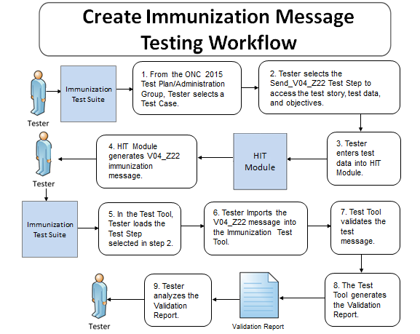

The instructions in the testing process listed below reference the numbered test steps in **Figure 1**.

Required Vendor Information

1. Vendor shall identify the Health IT Module function(s) that are available to 1) create patient records in the Health IT Module and input the test data for the test patients, 2) create immunization information messages using the test data, 3) import the immunization information messages to the Tool, and 4) demonstrate support for the named standard vocabulary value sets
2. Vendor shall provide the mechanism necessary to capture and import immunization messages into the Tool

Required Testing Actions

1. Using the HL7 Context-based capability provided in the Tool identified in the **Conformance Test Tools section** of this testing process document, the Tester shall access the **ONC 2015 Test Plan** and
   1. Select a Test Case in the Administration Group [Figure 1, Step 1]
   2. Select the Send_V04_Z22Test Step consisting of immunization information [Figure 1, Step 2]
2. Using the capabilities in the Health IT Module, the Tester shall
   1. Input the provided immunization information test data using the Test Data Specification in the Tool for the Test Step (input can be performed using a manual or automated process) [Figure 1, Step 3]
   2. Cause the Health IT Module to generate the indicated immunization information message [Figure 1, Step 4]
3. In the Tool, the Tester shall load the selected Send_V04_Z22Test Step and import the immunization information message generated by the Health IT Module [Figure 1, Steps 5 & 6]
4. Using the **Inspection Test Guide**, the Tester shall verify that the immunization information message is conformant to the **Referenced Standards** and that the message includes the specified immunization information

Inspection Test Guide

1. Using the Validation Report produced by the Tool**,** theTester shall analyze the Report and verify that the message created by the Health IT Module meets the conformance requirements in the **Referenced Standards** [Figure 1, Step 7, 8, & 9]
2. Once during the certification testing for this criterion, the Tester shall inspect the Health IT Module to verify its ability to support the named HL7 Standard Code Set CVX -- Vaccines Administered, the National Drug Code Directory – Vaccine Codes vocabulary standard, and the value sets specified in the HL7 v2.5.1 Implementation Guide for Immunization Messaging, Release 1.5 interoperability standard
3. Using the functions of the Health IT Module and Tool, the Vendor shall demonstrate to the Tester that their Health IT Module supports
   * The HL7 Standard Code Set CVX -- Vaccines Administered vocabulary standard for vaccines **in an historical record**
   * The National Drug Code Directory – Vaccine Codes **for administered vaccines**
   * The CDC-defined NIP003 – Immunization information source value set specified in the HL7 v2.5.1 Implementation Guide for Immunization Messaging, Release 1.5 interoperability standard
   * Another value set specified in the HL7 v2.5.1 Implementation Guide for Immunization Messaging, Release 1.5 interoperability standard and **selected at the tester’s discretion**

**IZ_DTR - 2: Receive and Process Acknowledgement (ACK) Messages**

Figure 2 Receive and Process HL7 v2.5.1 ACK Z23 Messages

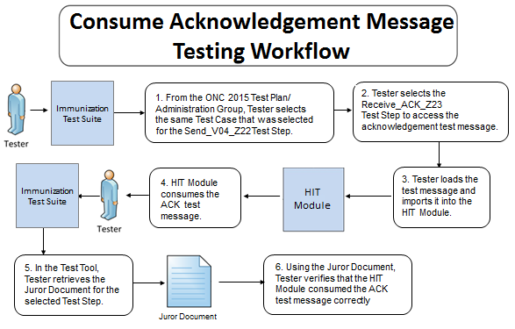

The instructions in the testing process listed below reference the numbered test steps in **Figure 2**.

Required Vendor Information

* Vendor shall identify the Health IT Module function(s) that are available to 1) import the Acknowledgement messages into the Health IT Module, and 2) verify that the Acknowledgement messages are processed according to the referenced standard
* Vendor shall provide the mechanism necessary to import the Acknowledgement messages into the Health IT Module

Required Testing Actions

1. In the Tool, Tester shall access the same Test Case selected previously for **IZ-DTR - 1: Create Immunization Information Messages** [Figure 2, Step 1] and shall
   1. Select the Receive_ACK_Z23 Test Step [Figure 2, Step 2]
   2. Load the test message [Figure 2, Step 3]
2. Using the capabilities in the Health IT Module, the Tester shall import the Acknowledgementmessage into the Health IT Module, and the Module will consume the message [Figure 2, Steps 3 & 4]
3. In the Tool, the Tester shall retrieve the Juror Document for the selected Receive_ACK_Z23 Test Step [Figure 2, Step 5]
4. Using the **Inspection Test Guide**, the Tester shall verify that the Health IT Module consumed the Acknowledgement message correctly

Inspection Test Guide

1. Using the Test Step-specific Juror Documentretrieved from the Tool**,** theTester shall inspect the Health IT Module and verify that the Module processed the Acknowledgement message according to the conformance requirements in the **Referenced Standards** as indicated by the instructions in the Juror Document [Figure 2, Step 6]
   1. For a positive Acknowledgement message, no notification need be made visible in the Health IT Module unless the Module was unable to process the message
   2. For Acknowledgement messages with ERR segments, the issue(s) identified in the error notification must be made visible in some manner in the Health IT Module

**IZ_DTR - 3: Create Evaluated Immunization History and Forecast Query Messages**

Figure 3 Create HL7 v2.5.1 Z44 Query Messages

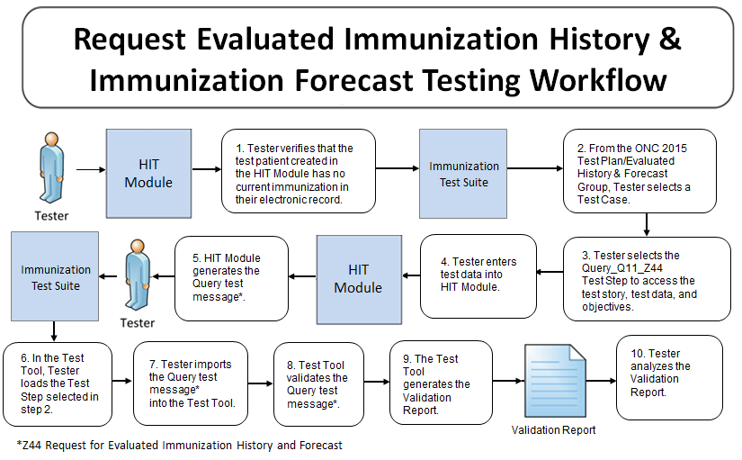

The instructions in the testing process listed below reference the numbered test steps in **Figure 3**.

Required Vendor Information

1. Vendor shall identify the Health IT Module function(s) that are available to 1) create patient records in the Health IT Module and input the test data for the test patients, 2) create evaluated immunization history and forecast query messages using the test data, and 3) import the query messages into the Tool
2. Vendor shall provide the mechanism necessary to capture and import evaluated immunization history and forecast query messages into the Tool

Required Testing Actions

1. Using the capabilities in the Health IT Module, the Tester shall verify that the test patient used for this DTR has no current immunization information stored in their electronic record [Figure 3, Step 1]
2. In the Tool, Tester shall access the ONC 2015 Test Plan and
   1. Select a Test Case in the Evaluated History and Forecast Group [Figure 3, Step 2]
   2. Select the Query_Q11_Z44Test Step [Figure 3, Step 3]
3. Using the capabilities in the Health IT Module, the Tester shall
   1. Input the provided immunization information test data using the Test Data Specification in the Tool for the Test Step (input can be performed using a manual or automated process) [Figure 3, Step 4]
   2. Cause the Health IT Module to generate the indicated Evaluated Immunization History and Forecast query message [Figure 3, Step 5)
4. In the Tool, the Tester shall load the selected Query_Q11_Z44Test Step and import the Evaluated Immunization History and Forecast query message generated by the Health IT Module [Figure 3, Steps 6 & 7]
5. Using the **Inspection Test Guide**, the Tester shall verify that the Evaluated Immunization History and Forecast query message is conformant to the **Referenced Standards** and that the message includes the specified query information

Inspection Test Guide

1. Using the Validation Report produced by the Tool**,** theTester shall analyze the Report and verify that the Evaluated Immunization History and Forecast query message created by the Health IT Module meets the conformance requirements in the **Referenced Standards** [Figure 3, Step 8, 9, & 10]

**IZ_DTR - 4: Receive and Display Evaluated Immunization History and Forecast Response Messages**

Figure 4 Receive and Process HL7 v2.5.1 Z42 or Z33 Messages

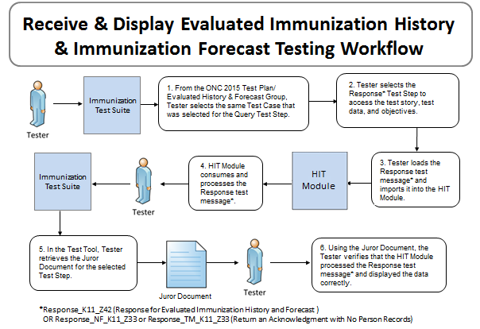

The instructions in the testing process listed below reference the numbered test steps in **Figure 4**.

Required Vendor Information

1. Vendor shall identify the Health IT Module function(s) that are available to 1) import the HL7 response messages into the Health IT Module, and 2) verify that the HL7 response messages are processed according to the referenced standard
2. Vendor shall provide the mechanism necessary to import the HL7 response messages into the Health IT Module

Required Testing Actions

1. In the Tool, Tester shall access the same Test Case selected previously for **IZ-DTR - 3: Create Evaluated Immunization History and Forecast Query Messages** [Figure 4, Step 1] and shall
   1. Select the Response (Response_K11_Z42, Response_NF_K11_Z33, or Response_TM_K11_Z33)Test Step [Figure 4, Step 2]
   2. Load the Response test message [Figure 4, Step 3]
2. Using the capabilities in the Health IT Module, the Tester shall import the Response test message into the Health IT Module, and the Module will consume the message [Figure 4, Steps 3 & 4]
3. In the Tool, the Tester shall retrieve the Juror Document for the selected Send ResponseTest Step [Figure 4, Step 5]
4. Using the **Inspection Test Guide**, the Tester shall verify that the Health IT Module consumed the Response message correctly

Inspection Test Guide

1. Using the Test Step-specific Juror Documentretrieved from the Tool**,** theTester shall inspect the Health IT Module and verify that the Module processed the Response message according to the requirements derived from the Immunization Messaging Guide and associated Addendum as indicated by the instructions in the Juror Document [Figure 4, Step 6]
   1. For a Response message that contains Evaluated Immunization History and Forecast information, the Health IT Module shall process the Response message and display the patient immunization information contained in the message (in a real-word setting, the patient immunization information in the message could be combined with information that is in the Health IT Module)
   2. For a Response message that contains *no matching records were found* information, the Health IT Module shall process the Response message and display a notification indicating that the query for the Evaluated Immunization History and Immunization Forecast is complete but no matching records were found for the person in the query
2. For a Response message that contains *too many matches were found* information, the Health IT Module shall process the Response message and display a notification indicating that the query for the Evaluated Immunization History and Immunization Forecast is complete but too many matches were found for the patient requested

### Test Data

Test data are provided for the testing process to ensure that the applicable requirements identified in the ONC criteria can be adequately evaluated for conformance, as well as to provide consistency in the testing process across multiple National Voluntary Laboratory Accreditation Program (NVLAP) -Accredited Testing Labs (ATLs). The provided test data focus on evaluating the basic capabilities required of the Health IT Module, rather than exercising the full breadth/depth of capability that installed Health IT Modules might be expected to support. The test data are formatted for ease of use by the Tester during the testing process; the format is not intended to prescribe the design of the display presented to the end-user for viewing the data. No additional requirements should be drawn from the format.

The Tester shall use and apply the provided test data during the testing, without exception, unless one of the following conditions exists:

* The Tester determines that the Health IT Module is sufficiently specialized that the provided test data need to be modified in order to conduct an adequate test. Having made the determination that some modification to the provided test data is necessary, the Tester shall record the modifications made as part of the test documentation.
* The Tester determines that changes to the test data will improve the efficiency of the testing process (for example, using consistent demographic data throughout the testing workflow). The Tester shall ensure that the functional and interoperable requirements identified in the criterion can be adequately evaluated for conformance, and that the modified test data provide a comparable level of robustness.

Any departure from the provided test data shall focus on meeting the basic capabilities required of the Health IT Module relative to the certification criterion rather than exercising the full breadth/depth of capability that installed Health IT Module might be expected to support.

Using the exact test data provided for the **Evaluated Immunization History and Forecast** Query and Response messages is imperative in order to support patient matching performed by the HIT Module being tested. The NIST RSP test message is populated with fixed data based on the data expected to be in the Module. If the exact test data provided for the Query message are altered, the test data in the Response message would need to be altered exactly the same way.

The testing process requires that the Tester enter the applicable test data into the Health IT Module being evaluated for conformance. The intent is that the Tester fully controls the process of entering the test data in order to ensure that the data are correctly entered as specified in the testing process. If a situation arises where it is impractical for a Tester to enter the test data directly, the Tester, at the Tester’s discretion, may instruct the Vendor to enter the test data, so long as the Tester remains in full control of the testing process, directly observes the test data being entered by the Vendor, and validates that the test data are entered correctly as specified in the testing process document.

For ONC Health IT Module certification testing, the primary purpose of the provided test data is to assist the Tester in verifying that the vendor’s Health IT Module is capable of supporting the required functions; verifying the ability to support the specific content is applicable only when the test data are categorized as, for example, “Value-Profile-Fixed” (see How to Interpret the Message Content Data Sheet section below for additional details about the categorization of test data). The clinical test data are relevant for the given Test Stories; however, these data should not be expected to represent standards of practice.

Test data for certification testing related to the §170.315(f)(1) Transmission to immunization registries ONC criterion are available in the Tool (see the Conformance Test Tools section of this test process document for instructions on how to access the Test Tool).

### Navigating a Test Case

An Immunization Messaging Test Case contains multiple Test Steps, each consisting of a Test Story, a Test Data Specification, a Message Content Data Sheet, and (if applicable) a Juror Document. All of these artifacts are accessible via the ONC 2015 Test Plan in the Tool.

* The Test Story describes a real-world situation that provides the context for the Test Step.
* The Test Data Specification provides the data associated with the Test Story and lists the information that would typically be available for a given situation in the specified clinical setting. Together, the Test Story and the Test Data Specification provide sufficient information for the Testers and Health IT Module Vendors to enter into the Module in order to create the HL7 v2.5.1 message for a particular Test Step. The message is to be created using these data and the Health IT Module functions.
* The Message Content Data Sheet shows a conformant message instance for the Test Step. The message content is organized in a table format that provides the HL7 v2.5.1 message elements and the data associated with the message elements for a given Test Step. The Message Content Data Sheet may provide assistance to the Tester and Health IT Module Vendor for resolving issues discovered during conformance testing. This data sheet can be thought of as the “answer” to the scenario (“question”) provided by the Test Story and the Test Data Specification.
* The Juror Document provides a checklist for the Tester to use during certification testing for assessing the Health IT Module’s ability to display required data elements from the information received in the immunization message. Additional data from the message or from the Health IT Module are permitted to be displayed by the Module. Grayed-out fields in the Juror Document indicate where no data for a given data element were included in the message for the particular Test Case. The format of the Juror Document is for ease-of-use by the Tester and does not indicate how the Health IT Module display must be designed.

For the Immunization Messaging ONC certification testing process, the Tester shall select the **ONC 2015 Test Plan** in the **HL7 Context-based** capability of the Tool. The ONC 2015 Test Plan **c**onsists of two Groups of Test Cases:

* 10 Administration Test Cases
* 4 Evaluated History and Forecast Test Cases

Each Test Case listed in the two Groups consists of a pair of Test Steps that are to be used together to test the Health IT Module for Message Created and Message Returned capabilities (the Test Steps provide data that may be used for an ambulatory or an inpatient Health IT Module). **Table 2** (Immunization Test Cases and Associated Test Steps) lists the two Groups, the Test Cases, and the two Test Steps for each Test Case.

**Table 2 Immunization Test Cases and Associated Test Steps**

| **Test Cases** | **Message Created – Step 1** | **Message Returned – Step 2** |
| --- | --- | --- |
| Administration Group | Send Administration Message | Consume Acknowledgement Message |
| IZ-AD-1_Admin_Child | IZ-AD-1.1_Send_V04_Z22 | IZ-AD-1.2_Receive_ACK_Z23 |
| IZ-AD-2_Admin_Adult | IZ-AD-2.1_Send_V04_Z22 | IZ-AD-2.2_Receive_ACK_Z23 |
| IZ-AD-3_Child_No_Consent | IZ-AD-3.1_Send_V04_Z22 | IZ-AD-3.2_Receive_ACK_Z23 |
| IZ-AD-4_Delete_Record | IZ-AD-4.1_Send_V04_Z22 | IZ-AD-4.2_Receive_ACK_Z23 |
| IZ-AD-5_Refusal | IZ-AD-5.1_Send_V04_Z22 | IZ-AD-5.2_Recieve_ACK_Z23 |
| IZ-AD-6_Update_Record | IZ-AD-6.1_Send_V04_Z22 | IZ-AD-6.2_Receive_ACK_Z23 |
| IZ-AD-7_Historical_IIS_Error | IZ-AD-7.1_Send_V04_Z22 | IZ-AD-7.2_Receive_ACK_Z23 |
| IZ-AD-8_Admin_IIS_Warning | IZ-AD-8.1_Send_V04_Z22 | IZ-AD-8.2_Receive_ACK_Z23 |
| IZ-AD-9_Admin_IIS_2Warnings | IZ-AD-9.1_Send_V04_Z22 | IZ-AD-9.2_Receive_ACK_Z23 |
| IZ-AD-10_Historical_IIS_SysError | IZ-AD-10.1_Send_V04_Z22 | IZ-AD-10.2_Receive_ACK_Z23 |
| Evaluated History and Forecast Group | Send Query Message | Receive Response Message |
| IZ-QR-1_Query_Child | IZ-QR-1.1_Query_Q11_Z44 | IZ-QR-1.2_Response_K11_Z42 |
| IZ-QR-2_Query_Adult | IZ-QR-2.1_Query_Q11_Z44 | IZ-QR-2.2_Response_K11_Z42 |
| IZ-QR-3_Query_No_Patients | IZ-QR-3.1_Query_Q11_Z44 | IZ-QR-3.2_Response_NF_K11_Z33 |
| IZ-QR-4_Query_Too_Many | IZ-QR-4.1_Query_Q11_Z44 | IZ-QR-4.2_Response_TM_K11_Z33 |

Details for each Test Step, including the test story, test objectives, test data, example HL7 message, and (if applicable) the Juror Document, are provided via the tabs that are displayed when a user selects a Test Step in the Context-based feature of the Tool, and also are available in PDF files accessible via the tabs displayed with the Test Step as well as via the Test Suite Documentation tab. The Tester shall follow the instructions in the **Normative Test Description** section of this testing process document to conduct the certification testing.

### How to Interpret the Message Content Data Sheet

The Message Content Data Sheet indicates the data that are to be included in the immunization test message based on the test data entered into the Health IT Module for a particular Test Step. **Table 3** shows a portion of a Message Content Data Sheet.

Table 3 Message Content Data Sheet Excerpt for PID Segment in an Immunization Message

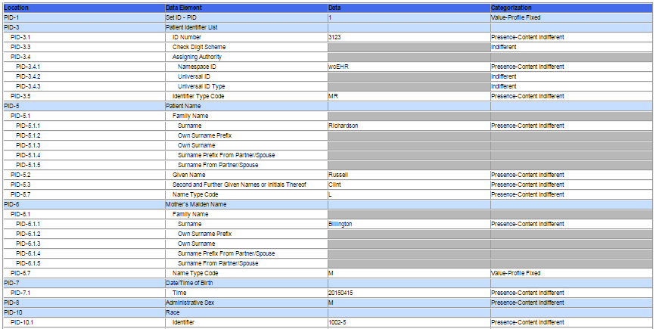

The information in the ***Location*** column indicates the canonical element location in the HL7 V2 message. For example, PID-3.5 represents the 5th component in the 3rd field of the PID segment. The ***Data Element*** column indicates the name of the data element as specified by the Immunization Messaging Guide. The ***Test Data*** column lists the data to be included for each Data Element in the immunization message created by the Health IT Module.

The ***Categorization*** column indicates the type and expected source of the data as well as how the Context-based feature in the Tool will validate the data for the given Data Element in the immunization message. In some cases the test tool validator simply examines the message element for the presence of data, whereas in other cases the validator examines the message element for the presence of data and for exact content. **Table 4** shows descriptions of the test data Categories and their associated Qualifiers.. Additional information about the test data Categories and Qualifiers is available in the *Understanding Immunization Messaging ONC Certification Testing Edition 2015* document, which is accessed via the Documentation tab in the NIST Immunization Test Suite.

Table 4 Test Data Categories, Associated Qualifiers, and Descriptions

| **Test Data Categorization** | **Description** | **Qualifier** | **Description** |
| --- | --- | --- | --- |
| **Indifferent** | No content is specified. | ***None*** | None |
| **Presence** | Example content is specified. | ***Content Indifferent*** | Content is expected to be present in the message, but not a specific value. |
| ***Configuration*** | Content is expected to be present in the message, but not a specific value. The value is usually determined at installations. |
| ***System Generated*** | Content is expected to be present in the message, but not a specific value. The value is system generated. |
| ***Test Case Proper*** | Content is expected to be present in the message, but not a specific value. However, content is expected to be consistent with the clinical test story. |
| **Presence-Length** | Example content is specified to a minimum length. | ***Same qualifiers as for Presence*** | Content of a minimum length is expected to be present in the message, but not a specific value. |
| **Value** | Specific content is specified. | ***Profile Fixed*** | Content is defined as a constant in the conformance profile. The constant is specified in the test data. |
| ***Profile Fixed - List*** | Content is defined as a set of allowable values in the conformance profile. One value from the allowable set is specified in the test data. |
| ***Test Case Fixed*** | Content that is defined as a constant in the test case. |
| ***Test Case Fixed - List*** | Content is defined as a set of allowable values in the test case. One value from the allowable set is specified in the test data. |
| **Non-presence** | No content is explicitly specified. | ***None*** | None |

Along with the Test Data Specification, the Message Content Data Sheet can be used to assist the Tester and Health IT Module Vendor in loading the test data into the Module for a given Test Step.

The Test Cases and the Context-based feature in the Tool are tightly-coupled. In addition to validating message conformance, the test tool performs selective content validation based on the test data provided, and deviation from the test data may cause the test tool to issue Error notifications. For this reason, the Tester should use the test data as specified.

### Conformance Test Tools

The following testing tools are available to evaluate conformance to the standards referenced in this testing process document:

* HL7 v2 Immunization Test Suite – an HL7v2 messaging validation tool; designed to support the NIST testing process for ONC Health IT Certification testing as well as other immunization message testing
* The tool is available as a Web Application
* The application can be downloaded for local installation
* The Immunization Test Suite Web Application is available at:

<http://hl7v2-iz-r1.5-testing.nist.gov/iztool>

Support for these tools is available by submitting questions to the following user’s group:

<https://groups.google.com/d/forum/hl7v2-immunization-testing>.

Inquiries may also be sent to this user group via email: [hl7v2-immunization-testing@googlegroups.com](mailto:hl7v2-immunization-testing@googlegroups.com)

Several browsers may be used to access the HL7 v2 Immunization Test Suite tool; Firefox or Google Chrome are the supported browsers. The Test Suite tool uses non-standard ports. If your firewall blocks HTTP traffic on non-standard ports, this tool may not be accessible. Please retry access from a location without a firewall that blocks non-standard ports. Alternatively users may download and run a local version of the tool.

The following information is provided to assist the Tester in interpreting the Validation Reports generated by the HL7v2 Immunization Test Suite tool:

The Context-based capability in the HL7v2 Immunization Test Suite tool evaluates conformance requirements that are specified or have been derived from the standards and implementation guides identified in the 2015 Edition of the ONC Final Rule and the test data provided for this testing process. The Test Suite tool evaluates the submitted HL7 message for each conformance requirement, and then produces a Validation Report.

The Tester should consider a Report that contains only Affirmative and Warning messages to be indicative of a sufficient level of conformance to the standard and test data expectations. If reported, Errors should be considered significant departures from the standard or test data requirements, and these Errors must be corrected in order to claim conformance. ATLs will need to further analyze each Error to determine if, in the context of meeting the criterion and overall meaningful use objective, the Error results in a failure of the testing process by the Health IT Module.

The NIST context-based testing performs specific content validation depending on the Category/Qualifier combination assigned to the Data Elements in the message (see How to Interpret the Message Content Data Sheet section for more details). In some cases, in order to perform this type of validation the NIST Tool expects the segments/segment groups in the message to be sequenced in a certain order. The complexity of automatically evaluating specific content necessitates this approach. If the Message Validation Result generated by the NIST Tool indicates content-related errors, the ATL may change the order of the segments/segment groups in the test message to match the Test Case once the message has been loaded into the Message Content window of the Test Tool. These kinds of content-related errors do not imply a failure of the vendor product nor a requirement to create the message with the segments/segment groups in a certain order (beyond the base message structure).

## Document History

## 

|  |  |  |
| --- | --- | --- |
| **Version Number** | **Description of Change** | **Date Published** |
| 1.0 | Released for public comment | Month DD, 201N |

1. This test verifies that the Health IT Module is capable of displaying the specified information in the message transmitted by the IIS. The Module may display information from the Health IT Module itself as well, but the information transmitted in the message from the IIS MUST BE displayed (since the message is processed in a test environment, the Module is only expected to know about the message the NIST Test Tool returns).
2. During certification testing, the mechanism by which the immunization test message is imported (sent) from or to the Health IT Module being tested is not specified. The ATL may have their own utility, they may allow the Module vendor to use a utility created by that vendor, or the message can be cut from the Module and pasted into the NIST Test Tool or cut from the NIST Test Tool and pasted into the Module. For certification testing, the key requirement is for the Module to demonstrate real time/dynamic import.